Cloud Computing:

Cloud computing is on-demand access to computing resources—physical or virtual servers, data storage, networking capabilities, application development tools, software, AI-powered analytic platforms and more over the internet with pay-per-use pricing.
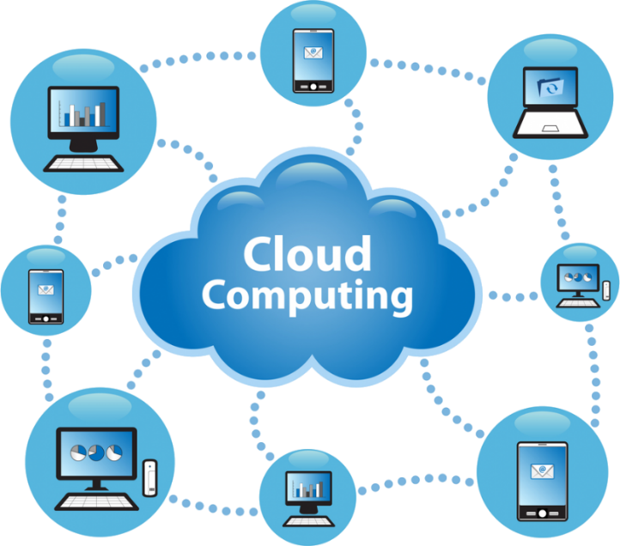

History of Cloud Computing
Before modern computing became widespread, organizations relied on client–server architecture, where all data and control resided on centralized servers. Users had to connect to the server to access resources, which worked but had drawbacks like limited scalability and high maintenance. To overcome these issues, distributed computing emerged, allowing multiple computers to share resources over a network. While this improved flexibility, it still had limitations in consistency and management. The idea of cloud computing—computing delivered as a utility—was first proposed in 1961 by John McCarthy at MIT, who envisioned computing services provided like water or electricity. At the time, the concept was not widely accepted, but years later, the industry began to adopt it.
The first major implementation came in 1999 when Salesforce delivered enterprise applications over the internet, introducing software as a service. In 2002, Amazon launched Amazon Web Services (AWS), and by 2006, it introduced Elastic Compute Cloud (EC2), making scalable computing available to everyone online. Other tech giants soon followed: in 2009, Google began offering cloud-based enterprise applications, and Microsoft launched Azure the same year. Companies like IBM, Oracle, HP, and Alibaba also entered the market, accelerating the growth of cloud computing. Today, cloud computing is a mainstream technology, providing on-demand infrastructure, platforms, and software globally, and has become an essential skill in the modern IT landscape.
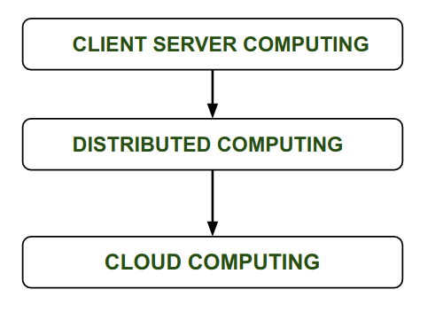

Advantages of Cloud Computing
1. Scalability
One of the greatest advantages of cloud computing is its scalability. Running a business or organization is challenging even under normal circumstances, and unexpected events such as economic downturns, inflation, pandemics, wars, workforce changes, or supply chain disruptions make it even harder. Cloud computing gives companies the flexibility to scale resources at their own pace. While long-term planning is important, the world is unpredictable. Whether you need to grow rapidly, expand cautiously, or reduce operations during uncertain times, cloud computing allows you to adjust quickly. You only pay for what you use, making it a cost-effective and strategic resource for businesses.
2. Security
Security is one of the most important benefits of cloud computing. Traditional on-premises systems often leave small businesses exposed because they lack the resources for advanced protection. Cyberattacks are increasing every year, and many small organizations underestimate the risk. Cloud providers offer enterprise-grade security features such as data encryption, firewalls, and continuous 24/7 monitoring—capabilities that most businesses cannot afford to maintain in-house. By migrating to the cloud, companies gain access to robust security standards and automated threat detection, reducing the chances of breaches and ensuring compliance with industry regulations.
3. Accessible to modern technology
Cloud computing is not just about storing data online—it opens the door to advanced technologies that drive innovation and efficiency. Modern businesses can access powerful tools and services through cloud platforms without investing in expensive infrastructure. These include Artificial Intelligence and Machine Learning for smarter decision-making, Data Analytics and Visualization for actionable insights, and containerization for scalable application deployment. By leveraging these technologies on the cloud, organizations can stay competitive, adapt quickly to market changes, and deliver better products and services.
4. Cheaper
Cloud computing works on a simple principle: pay only for what you use. This model gives businesses an affordable way to stay organized and online without heavy upfront costs. Even though hardware like servers and storage devices has become cheaper over the years, maintaining an in-house data center still adds up—between purchase, upgrades, and ongoing maintenance. With the cloud, companies skip all that hassle. Instead of buying physical infrastructure, they pay a subscription fee for reliable, scalable services. It’s a smarter, more flexible approach that saves money and frees organizations from managing hardware themselves.
5. Mobility
One of the biggest benefits of cloud computing is mobility. Employees can access data and run even heavy workloads from anywhere—whether they’re at home, in the office, or on the go. With remote work and flexible schedules becoming the norm, the ability to keep information and workflows in sync through the cloud is no longer a luxury; it’s a smart investment. This flexibility helps maintain productivity while supporting work-life balance, making cloud computing an essential tool for modern businesses
6. Easy Collaboration
One of the most valuable benefits of cloud computing, closely tied to mobility, is effortless collaboration. It’s not just about making your data and applications accessible from anywhere—it’s about bringing people together to work seamlessly. In traditional setups, gathering information from different teams, organizing it, and avoiding errors or duplicates can be a real challenge. Cloud services simplify this process by providing a single source of truth for everyone—whether they’re in different departments, offices, or even countries. This means faster information sharing, fewer mistakes, and quicker decisions, all while ensuring that everyone is working on the same up-to-date data.

On premise vs On Cloud:
On Premises: In an on-premises setup, everything—from installation to ongoing operations—is managed internally. Backup, privacy, and updates must be handled in-house. Once the software is purchased, it is installed on your own servers, which requires additional hardware, database software, and operating systems. This approach gives you complete ownership but also demands significant investment in infrastructure and skilled personnel.

On Cloud: Cloud computing delivers on-demand services over the internet using a “pay-as-you-use” model. Instead of managing files and services on local storage, you can access them online in a cost-efficient way. With a cloud-based subscription model, there is no need to purchase additional hardware or licenses, and scaling resources becomes much simpler.
Difference between On-Premises and On Cloud:
- Scalability –
On-premises systems require heavy investment to scale and make it difficult to scale down, leading to high infrastructure and maintenance costs. Cloud solutions allow you to scale up or down easily and pay only for what you use.
- Server Storage –
On-premises setups need physical space, power, and maintenance for servers. Cloud providers handle storage and server maintenance, saving money and space.
- Data Security –
On-premises security relies on physical and traditional IT measures, which can be costly and less effective. Cloud platforms offer advanced security features, including encryption and continuous monitoring
- Data Loss or Recovery –
Recovery from data loss in on-premises systems is slow and limited. Cloud solutions provide automated backups and faster recovery options.
- Maintenance –
On-premises systems require dedicated IT teams for maintenance, increasing costs. Cloud services are maintained by the provider, reducing operational overhead

